**TEST**

**PRODUCT**

**QUALIFICATION**

**REPORT**

**TITLE:**

LT3685 Test Site Transfer from Analog Devices Singapore to

Analog Devices General Trias Philippines

**PCN Number:**

PCN 20_0231

**REVISION:**

A

**DATE:**

September 2020

**CONTENTS:**

**Summary**

**Table 1** – LT3685 Test Details

**Table 2** – Product Correlation Representative Identification

**Table 3 –** Qualification Activities and Acceptance Criteria

**Table 4** – Correlation Device Run Results

**Table 5** – Product Site Transfer Correlation

**Table 6 –** Manufacturing Validation Lot Run

**Table 7 –** GR&R Result

**PROJECT BACKGROUND:**

The LT3685 is currently undergoing production testing at the Analog Devices Singapore (ADSG). It was a strategic decision from business standpoint to qualify Analog Devices General Trias (ADGT) which will soon serve as production site after ADSG closure. ADGT is situated in Gateway Business Park, General Trias, Cavite, Philippines. The manufacturing facility have 1 Million square foot building in a 15 hectares land area. It houses ~900 Testers and ~1000 handlers with 4,850 total employees which includes 1,000 engineers composed of Test, Product, Failure Analysis, Reliability, Design and Layout Engineers. ADGT passed and qualified on different certifications such as: IATF 16949, ISO 9001, ISO 14001, OHSAS 18001, ANSI ESD S20.20, IEC 61340-5-1. The plant produces 375 Million test output per quarter and caters different testing capability such as Package Testing, WLCSP Testing and Die Preparation, Wafer Trim and Probe and Mil-Aerospace Assembly & Test. In terms of product test capability, ADGT caters testing for Automotive, RF, Power, MEMS, µIsolators, Mixed Signal High Speed Precision Converters and Mil-Aerospace products. After qualification and replication of necessary test capability, ADGT will serve as the primary test site facility to serve future demands.

**SUMMARY:**

The LT3685 is an adjustable frequency (200kHz to 2.4MHz) monolithic step-down switching regulator that accepts input voltages up to 38V operating and 60V maximum. An internal overvoltage protection circuit turns off the power switch when VIN is above 38V typical (36V minimum) which then allows the part to safely withstand 60V transients. A high efficiency 0.25 switch is included on the die along with a boost Schottky diode and the necessary oscillator, control, and logic circuitry. Current mode topology is used for fast transient response and good loop stability. The LT3685’s high operating frequency allows the use of small, low cost inductors and ceramic capacitors resulting in low output ripple while keeping total solution size to a minimum. The low current shutdown mode reduces input supply current to less than 1μA while a resistor and capacitor on the RUN/SS pin provide a controlled output voltage ramp (soft-start). A power good flag signals when VOUT reaches 89% of the programmed output voltage.

**TEST AND PRODUCT INFORMATION:**

Device: LT3685

Package: 10-LEAD 3mm x 3mm PLASTIC DFN

Leads: 10 LEADS

FG Partname: LT3685EDD#TRPBF

Tester Platform: LTX

Handler: RASCO1000

The LT3685 is planned to be tested in Analog Devices General Trias (ADGT) using the following as shown in the Table 1 below:

***Table 1****: LT3685 Test Details*

|  |  |  |  |
| --- | --- | --- | --- |
| **Parameters** | **ADSG** | **ADGT** | **Remarks** |
| Tester Platform | LTX TS80/TS88/MV88/EXP | LTX TS80/TS88/MV88/EXP | No change |
| Handler | RASCO1000 | RASCO1000 | No Change |
| Test Flow | FT_Room 100%-QAR-QAC-QACM-QAH | FT_Room 100%-QAR- QAC-QACM-QAH | No Change |
| Contactor | JT-3X3-DFN10-3771 | LTC-00020 | No Change  (Apply ADI Hardware naming standard) |
| Test Board | LT3481 Testcard | L-07154 | No change  (Apply ADI Hardware naming standard) |
| Test Program | EFR3685  EQR3685  EQL3685  EQH3685 | V17272P62  V17272P65  V17272P64  V17272P63 | No change  (Apply ADI Program Filename Standard) |

There is no change to the form, fit and function of the product.

This report documents the successful completion of the product test transfer requirements of LT3685 at ADGT.

**DESCRIPTION AND TEST RESULTS:**

To qualify LT3685EDD#TRPBF, LT3685IMSE#TRPBF, a 36V, 2A, 2.4MHz Step-Down Switching Regulator was identified as product correlation representative based on the following criteria: same product technology, same tester platform, same handler and same testcard. Being same generic of LT3685, both LT3685EDD and LT3685IMSE have the same product technology and functionality that can be configured as Step-down Converter. Both have the same features, specifications and have the same test coverage on all critical datasheet parameters, differs only on packaging. Comparison were analyzed and summarized at Table 2.

**Table 2:** *Product Correlation Representative Identification*

|  |  |  |  |  |  |
| --- | --- | --- | --- | --- | --- |
| **Part Name** | **Technology** | **Description** | **Test Platform** | **Handler** | **Test Coverage** |
| LT3685IMSE#TRPBF | Switching Regulators | 36V, 2A, 2.4MHz Step-Down Switching Regulator | LTX | RASCO1000 | All critical datasheet parameters are covered by LT3685IMSE |
| LT3685EDD#TRPBF | Switching Regulators | 36V, 2A, 2.4MHz Step-Down Switching Regulator | LTX | RASCO1000 |

Below tables provide description of the qualification tests conducted and corresponding test results for LT3685IMSE.

All the units have undergone electrical tests on both the sending and receiving sites on the same test platform. Any device that will not meet the electrical qualification requirements will mean failure of the qualification and require solid corrective actions and a repeat of the qualification process. Qualification activities performed, and acceptance criteria is shown on Table 3:

**Table 3:** *Qualification Activities and Acceptance Criteria*

|  |  |  |
| --- | --- | --- |
| **Qualification Activity** | **Sample Quantity** | **Accept Criteria** |
| Correlation device run | 5 correlation device units | *100% Passing correlation devices |
| Correlation Lot Run | Minimum of 300 known Bin1 units tested in full product test flow (ALL temperature passes). Test lot in Sending site (ADSG) and Receiving site (ADGT). | *CpK≥1.67 * For tightened limits, Mean Shift Criteria and sigma-spread criteria to apply * Mean Shift Criteria   (ABS (SS_mean - RS_Mean) / Limit Range ) x 100 ≤ 5% * Sigma-spread criteria * (RS_Sigma / SS_Sigma ) ≤ 1.3 |
|
| Validation Lot Run | Minimum of 1,000 fresh units in full product test flow (ALL temperature passes) | Split lot yield comparison between sending site vs. receiving site should match |
| Untrimmed/Fresh unit verification using QA program | 5 Fresh (Untrimmed) unit tested in QA Program. | QC program must detect untrimmed or fresh parts |
| GR&R | 10 Bin 1 units tested on 1 board and 3 testers | R&R % =<10% |

* *SS = Sending Site*
* *RS = Receiving Site*

To validate full set-up functionality such as hardware, software, test paraphernalia and tester platform, 5 correlation devices of LT3685IMSE were tested both in ADSG and ADGT. Data between sites were analyzed and summarized in Table 4.

**Table 4:** *Correlation Device Run result*

|  |  |  |  |
| --- | --- | --- | --- |
| **Generic** | **Package** | **No. of correlation device** | **ALL correlation devices passed?** |
| LTC3685 | 10-LEAD PLASTIC MSOP | 5 units | YES |

The LT3685IMSE was qualified by testing a correlation lot with minimum 300 units both in ADSG and ADGT. This is to capture variation in hardware, tester and set-up condition thru mean shift and sigma spread. This is to ensure the parameter measurement are still within the accepted range of variations. Data between sites were analyzed and summarized in Table 5.

**Table 5:** *Product Site Transfer Correlation*

|  |  |  |  |  |  |  |  |  |
| --- | --- | --- | --- | --- | --- | --- | --- | --- |
| **Temperature** | **Generic** | **Package** | **Lot Number** | **Lot Size** | **Sending Site** | **Receiving Site** | **Total No. of Correlation Parameters** | **Result** |
| Ambient | LT3685 | 10-LEAD PLASTIC MSOP | 1039379.5 | 475 | ADSG | ADGT | 28 | ALL PASSED |
| Hot | LT3685 | 10-LEAD PLASTIC MSOP | 1039379.5 | 475 | ADSG | ADGT | 28 | ALL PASSED |
| Cold | LT3685 | 10-LEAD PLASTIC MSOP | 1039379.5 | 475 | ADSG | ADGT | 28 | ALL PASSED |

The LT3685IMSE was qualified by running a validation lot with 2500 units in ADGT and was compared to ADSG split lot of the same fablot. Data between ADGT and ADSG lot performance were analyzed and summarized in Table 6.

**Table 6:** *Manufacturing Validation Lot Run*

|  |  |  |  |  |  |
| --- | --- | --- | --- | --- | --- |
| **Generic** | **Package** | **FabLot Number** | **Lot Size** | **Test Site** | **Split lot yield comparison between ADSG and ADGT** |
| LT3685 | 10-LEAD PLASTIC MSOP | W1938341.1 | 1000 units | ADSG | MATCHED |
| LT3685 | 10-LEAD PLASTIC MSOP | W1938341.1 | 2500 units | ADGT |

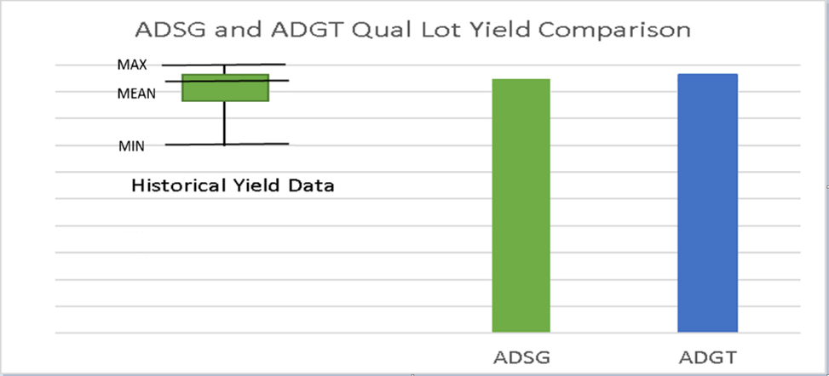

To ensure QA Program does not trim untrimmed/fresh parts, samples of untrimmed or fresh parts were tested using QA Program. LT3685 has no trimming on final test, criteria not applicable.

To gather test performance data to allow estimation of the overall test repeatability and reproducibility from the production test solution, GR&R was performed on 10 serialized units tested on 1 test board and 3 test systems. GR&R result was analyzed and summarized in Table 7.

**Table 7:** *GR&R Result*

|  |  |  |  |  |  |  |
| --- | --- | --- | --- | --- | --- | --- |
| **Generic** | **Package** | **Lot Number** | **No. of Units** | **No. of Test Boards** | **No. of Testers** | **All parameters passed R&R % =<10%?** |
| LT3685 | 10-LEAD PLASTIC MSOP | 1039379.5 | 10 | 1 | 3 | YES – ALL PASSED |

**APPROVALS:**

Technical Review Board No. [60579](http://wwmbe.analog.com/apps/mcm/projects/b5010606-3597-2a49-c640-39e8923e2093) - ADSG to ADGT Test Transfer

**ADDITIONAL INFORMATION:**

Homepage: <https://www.analog.com/en/index.html>

Customer Service: <https://www.analog.com/en/support/technical-support.html>